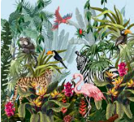
Jungle Class

Summer 1- 2024

We are excited to be starting the first half of our summer term. We have lots of lovely things to look forward to and we hope to be spending much more time outside as the weather improves!

Topic
We will be covering two topics this half term. Creep, Crawl and Wriggle and On the Beach.
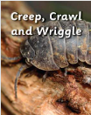
In the Creep, Crawl and Wriggle project, your child will learn about minibeasts. They will observe minibeasts in their natural habitats and create shelters for them to live in. They will learn about the life cycle of a butterfly and explore what minibeasts, such as snails and worms, need to survive. They will compare the features of minibeasts and learn the names of their body parts.


In the On the Beach project, your children will learn about animals that live in rock pools and on the seashore. They will compare their experiences with beach holidays in the past. They will learn about the animals that live in the sea and find out about worldwide seas and oceans. They will explore the importance of looking after the environment to keep living things safe. They will learn about staying safe at the beach and find out about people who help us.
Reading and phonics

Year 1 - This half term the Year 1 children will be continuing to look at the Level 5 Phonics . This introduces the children to alternative graphemes. It includes: 'ie' saying /ee/, 'tch' saying /ch/, 'are' and 'ear' saying /air/, 've' saying /v/ and 'ore' saying /or/. Also the children will be exposed to words with the suffixes: -ed, -s, -es, -er, -est, -ing and the prefix: un-.We will also continue to recap and practice sounds and tricky words from last half term. In their writing they will be focusing on using adjectives, verbs and using conjunctions to extend their sentences.

Reception – We will be reading and spelling level 4 tricky words. Blending to read ccvc words and spelling words such as clap, step, swim, spoon. The children will also be beginning to write captions and dictated sentences with ccvc words and tricky words. They will be encouraged to work as independently as possible, using their sound mats to help them.

Reading at home
At this age reading is a priority and we cannot emphasise enough how hearing your child read at home can make a huge difference to the progress they make. Please encourage your child to read regularly, daily if possible, and make some time to discuss the text with them. Don’t forget to record in their reading record books so that we know how they are getting on at home. As we also read with the children in school they need to bring in their reading books and their reading record books into school everyday

Library books
All children will have the opportunity to bring home books from our class and school library. Books will be changed every Monday so please could you make sure your child brings their book back on that day.

Maths- Year 1 Reception

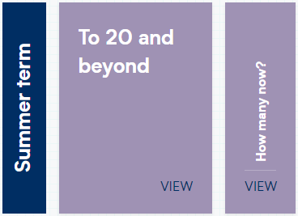
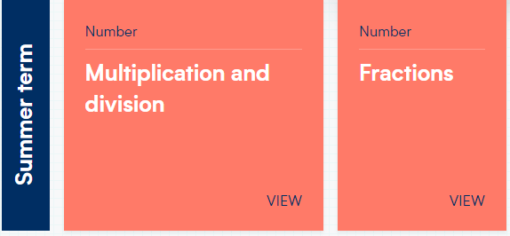


PE
PE will happen on Mondays and Thursdays. Monday’s session will be taught by Mrs Bray and will be focusing on Sending and Receiving. Thursday’s session will be taught by Mrs Panther and will be Games. Don’t forget that children will need to come into school on these days dressed in their PE kits. We will be using our outside space for PE so the children will need water bottles and a sun hat/cap.

Jigsaw- PSHE Relationships

In this Puzzle (unit) children will be learning about:
Children are introduced to the key relationships in their lives. They learn about families and the different roles people can have in a family. They explore the friendships they have and what makes a good friend. They are introduced to simple strategies they can use to mend friendships. The children also learn about Jigsaw’s Calm Me and how they can use this when feeling upset or angry.

RE

RE
This half term we will be continuing to look at Judaism, this time through considering the big question - "Why is the Torah such a joy for the Jewish Community?". We will be looking at stories from the Torah and what they teach Jewish people about God. We will also be learning about the celebration of Simchat Torah.

If you ever have any questions, concerns or exciting news you would like to share then please make sure you catch us at drop off and pick up times.

Best wishes
Mrs Bray and Mrs Panther

